7-Day Rwanda Golden Monkeys, Uganda Gorillas, & Chimps
This 7-day safari highlights gorilla trekking in Uganda and Golden Monkey Tracking in Rwanda, wildlife viewing at Queen Elizabeth National Park and chimpanzee trekking in Uganda. For those that want a short Rwanda and Uganda safari, this package is ideal for you because it lasts for a week. Optional transfer methods can be arranged upon request

Rwanda
Start | Kigali (Day 1)
Day 1 | Volcanoes NP (Gorillas)
Uganda
Day 2-3 | Bwindi Impenetrable NP (Gorillas)
Day 4-5 | Queen Elizabeth NP
Day 6 | Kibale NP (Chimps)
End | Entebbe (City) (Day 7)

Tour Features

Mid-range tour
This mid-range tour uses lodges.

Private tour
This tour will be organized exclusively for you and won't be shared with others.

Can be customized
You can request changes to this tour.

Suitable for solo travelers
Solo travelers can book this private tour.
15

Minimum age of 15 years
The minimum age for this tour is 15 years.

Activities & Transportation

Activities: game drives, gorilla trekking, chimpanzee trekking & boat trip

Game drives: pop-up roof 4x4 vehicle

Getting around: pop-up roof 4x4 vehicle

A transfer from and back to the airport is included

Accommodation & Meals
- Additional accommodation before and at the end of the tour can be arranged for an extra cost
- Day
Accommodation
- 1
Tiloreza Volcanoes Ecolodge Mid-range lodge just outside Volcanoes NP (Gorillas, Rwanda) – Lunch & Dinner Included

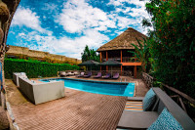

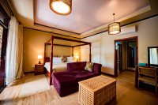

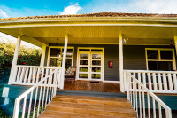+2Photos

- 2-3
Bweza Gorilla LodgeMid-range lodge just outside Bwindi Impenetrable NP (Gorillas, Uganda) – All Meals Included

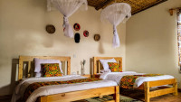

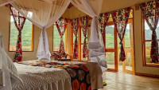

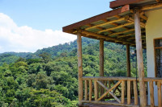+2Photos

- 4-5
Elephant Hab LodgeMid-range lodge just outside Kyambura Gorge (Chimps, Uganda) – All Meals Included

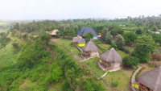

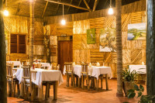

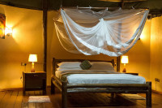+8Photos

- 6
Turaco Treetops LodgeMid-range lodge bordering Kibale NP (Chimps, Uganda) without fences – All Meals Included

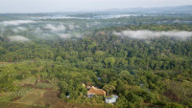

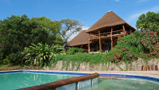

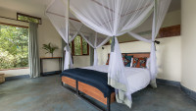+19Photos

- 7
End of tour
(No accommodation) – Breakfast & Lunch Included

Day by day program

Arrival
- You'll be collected from the airport.
- Accommodation before the tour starts can be arranged for an extra cost.
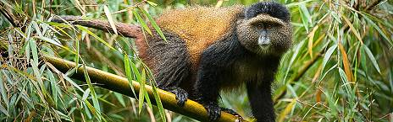

Day 1

Arrival & Transfer to Volcanoes National Park
You will be welcomed by your driver or guide and transferred to Ruhengeri—the base town of Volcanoes National Park. This is a 2 hours drive journey thru the scenic hills of Rwanda. You will have numerous stop overs for taking pictures or for using a restroom.
You can Opt to Visit the Kigali Genocide Memorial before leaving Kigali City.
Main Destination:
Volcanoes National Park (Gorillas)
Best Time To VisitJune to August (It is drier and hiking is easier)
High SeasonJune to September (Permits are scarce)

Wildlife in Volcanoes NP
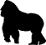
GorillaCommon

ChimpanzeeNone

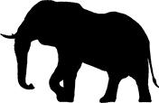
ElephantRare


BuffaloRare


White RhinoNone


Black RhinoNone

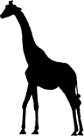
GiraffeNone


LionNone


LeopardNone


CheetahNone

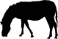
ZebraNone

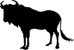
WildebeestNone


HippoNone
Accommodation:
Tiloreza Volcanoes Ecolodge
- Mid-range lodge just outside Volcanoes NP (Gorillas, Rwanda)





+2Photos

Meals & Drinks:
- Lunch & dinner (Breakfast not included)
- Drinking water (Other drinks not included)
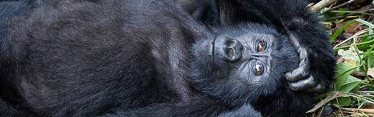

Day 2

Golden Monkey Tracking in Rwanda & Transfer to Uganda
Wake up to an early breakfast and transfer to the park headquarters for briefing. Later, proceed for Golden Monkey tracking activity on the bamboo slopes of Volcanoes National Park. Golden monkey trekking in Rwanda usually lasts a few hours (2 to 6). From the trek, have lunch and drive to Uganda via Cyanika border proceeding to Bwindi impenetrable National Park arriving late in the afternoon.
Main Destination:
Bwindi Impenetrable National Park (Gorillas)
Best Time To VisitJune to August and December to February (Gorilla trekking is easiest)
High SeasonJune to September (Gorilla permits are scarce)

Wildlife in Bwindi Impenetrable NP

GorillaCommon

ChimpanzeeRare


ElephantRare


White RhinoNone


Black RhinoNone


LionNone


GiraffeNone


LeopardNone


CheetahNone


BuffaloNone


ZebraNone


WildebeestNone


HippoNone
Accommodation:
Bweza Gorilla Lodge
- Mid-range lodge just outside Bwindi Impenetrable NP (Gorillas, Uganda)





+2Photos

Meals & Drinks:
- All meals included
- Drinking water (Other drinks not included)
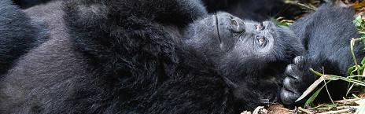

Day 3

Gorilla Trekking in Bwindi Impenetrable National Park
After enjoying an early breakfast, report to the park headquarters for a vital briefing and allocation of the gorilla family before you set off gorilla trekking. Enter the forest trekking through the steep, densely forested hills. Finally coming across the gorillas camouflaged in the vegetation is an inspiring and privileged moment. Tracking in the Bwindi forest requires stamina and can often take most of the day.
Main Destination:
Bwindi Impenetrable National Park (Gorillas)
Accommodation:
Bweza Gorilla Lodge
- Mid-range lodge just outside Bwindi Impenetrable NP (Gorillas, Uganda)
Meals & Drinks:
- All meals included
- Drinking water (Other drinks not included)
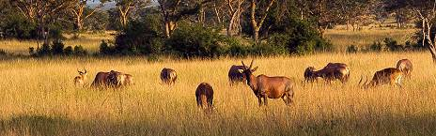

Day 4

Transfer to Queen Elizabeth National Park
Transfer to Queen Elizabeth National Park after enjoying your breakfast. Upon your arrival, you will enjoy a game drive in Ishasha sector for the tree climbing lions. Afterwards, transfer to the lodge and rest. The animal species to view here include; the lions, elephants, antelopes and birds.
Main Destination:
Queen Elizabeth National Park (Uganda)
Best Time To VisitJanuary to February and June to July (Dry seasons)
High SeasonJune to September (Peak time for Uganda)

Wildlife in Queen Elizabeth NP
ChimpanzeeOccasional


ElephantCommon


LionCommon


BuffaloCommon


HippoAbundant


LeopardOccasional


GiraffeNone


White RhinoNone


Black RhinoNone


CheetahNone


ZebraNone


WildebeestNone

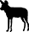
Wild DogNone
Accommodation:
Elephant Hab Lodge
- Mid-range lodge just outside Kyambura Gorge (Chimps, Uganda)





+8Photos

Meals & Drinks:
- All meals included
- Drinking water (Other drinks not included)
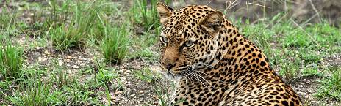

Day 5

Morning Game Drive & A Boat Cruise on Kazinga Channel
Enjoy breakfast and then proceed for the morning game drive within the park. You'll get a chance to view many animal species that you would have missed on the previous game drives. Return to the lodge and enjoy lunch as you prepare for a boat cruise on... Read more
Main Destination:
Queen Elizabeth National Park (Uganda)
Accommodation:
Elephant Hab Lodge
- Mid-range lodge just outside Kyambura Gorge (Chimps, Uganda)
Meals & Drinks:
- All meals included
- Drinking water (Other drinks not included)
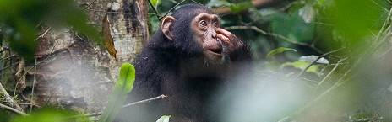

Day 6

Transfer to Kibale N/P & Afternoon Chimpanzee Tracking
Enjoy breakfast in the morning and then proceed with your drive to Kibale Forest National Park which is known for the highest concentration of primates in Uganda. Have an afternoon Chimpanzee trekking experience in the world's Primate Capital. Chimpanzee trekking usually takes 3 to 5 hours.
Main Destination:

Kibale National Park (Chimps)
Best Time To VisitJanuary to February and June to July (Chimp trekking is easiest)
High SeasonJune to September (Peak time for Uganda)

Wildlife in Kibale NP
ChimpanzeeCommon


ElephantOccasional


BuffaloOccasional


LionVery Rare


LeopardVery Rare


HippoRare


GiraffeNone


White RhinoNone


Black RhinoNone


CheetahNone


ZebraNone


WildebeestNone
Accommodation:
Turaco Treetops Lodge
- Mid-range lodge bordering Kibale NP (Chimps, Uganda) without fences





+19Photos

Meals & Drinks:
- All meals included
- Drinking water (Other drinks not included)
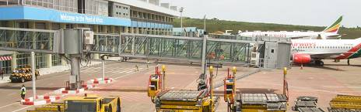

Day 7

Transfer To Entebbe International Airport or Kigali
You can opt for morning activities such as the Bigodi Swamp Walk and the Bigodi Cultural Tour, you can also opt to transfer back to Kigali or proceed to Entebbe International Airport for your departure flight. Optional Domestic Flights for 1 hour can be arranged at extra Costs, Just let us know what you prefer.

Main Destination:
Entebbe (City, Uganda)
Accommodation:
No accommodation (End of tour)
Meals & Drinks:
- Breakfast & lunch (Dinner not included)
- Drinking water (Other drinks not included)

End of tour
- Additional accommodation can be arranged for an extra cost.
- You'll be dropped off at the airport

Rates Per Person
Jan 1, 2025 - Dec 31, 2025
Per person
Solo traveller (1 room)
$4,862
2 people (1 room)
$3,190
3 people (2 rooms)
$2,998
4 people (2 rooms)
$2,849
5 people (3 rooms)
$2,783
6 people (3 rooms)
$2,635

Included
- Park fees(For non-residents)
- Gorilla permits(One per person, non-resident)
- Chimp permits(One per person, non-resident)
- All activities(Unless labeled as optional)
- All accommodation(Unless listed as upgrade)
- A professional driver/guide
- All transportation(Unless labeled as optional)
- All Taxes/VAT
- Roundtrip airport transfer
- Meals(As specified in the day-by-day section)
- Drinking water(On all days)

Excluded
- International flights(From/to home)
- Additional accommodation before and at the end of the tour
- Tips(Tipping guideline US$10.00 pp per day)
- Personal items(Souvenirs, travel insurance, visa fees, etc.)
- Government imposed increase of taxes and/or park fees

